Project details are available from page 13

Project 01

In this project, you will develop a simple Node.js application, deploy it on a local Kubernetes cluster using Minikube, and configure various Kubernetes features. The project includes Git version control practices, creating and managing branches, and performing rebases. Additionally, you will work with ConfigMaps, Secrets, environment variables, and set up vertical and horizontal pod autoscaling.

Project 01

Project Steps

1. Setup Minikube and Git Repository

Set Up Git Repository
Create a new directory for your project:
Initialize Git repository:
Create a .gitignore file:
Add and commit initial changes:

2 Develop a Node.js Application

Create the Node.js App
Initialize the Node.js project:
Install necessary packages:
Create app.js:
Update package.json to include a start script:
Commit the Node.js Application
Add and commit changes:

3. Create Dockerfile and Docker Compose

Create a Dockerfile
Add Dockerfile:
Create a .dockerignore file:
Create docker-compose.yml (optional for local testing)
Add docker-compose.yml:
Add and commit changes:
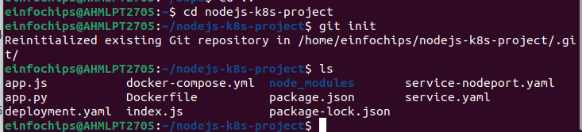

4. Build and Push Docker Image

Build Docker Image
Build the Docker image:
docker build -t nodejs-app:latest .
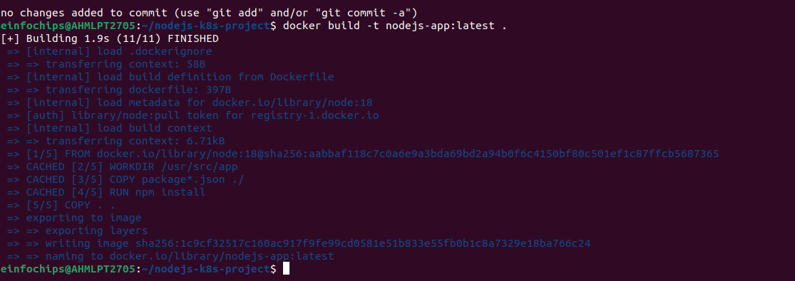

Push Docker Image to Docker Hub
Tag and push the image:
docker tag nodejs-app:latest your-dockerhub-username/nodejs-app:latest
docker push your-dockerhub-username/nodejs-app:latest
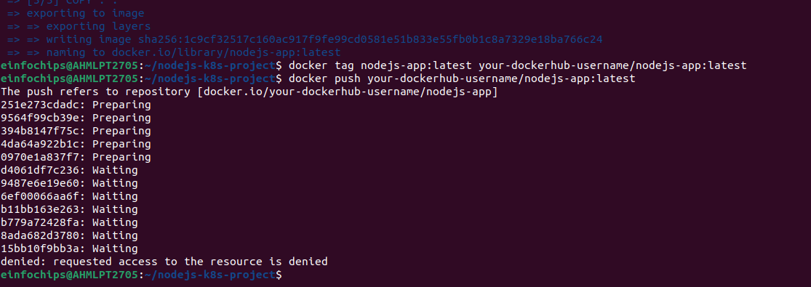
Add and commit changes:
git add .
git commit -m "Build and push Docker image"
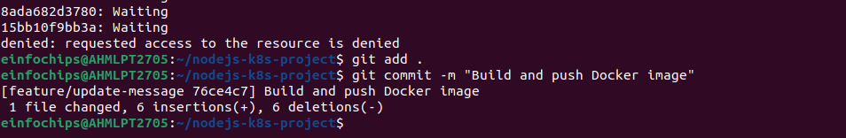

5. Create Kubernetes Configurations

Create Kubernetes Deployment

Create ConfigMap and Secret
Create kubernetes/secret.yaml:
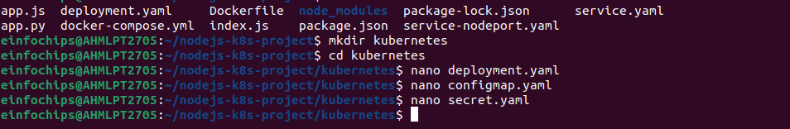
Add and commit Kubernetes configurations:
git add kubernetes/
git commit -m "Add Kubernetes deployment, configmap, and secret"
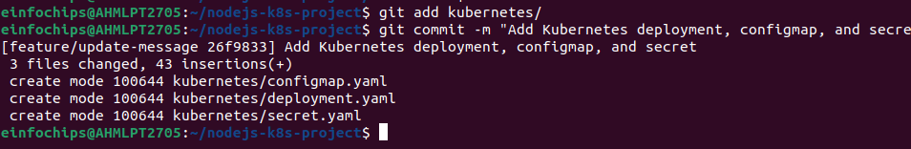

5.3 Apply Kubernetes Configurations
Apply the ConfigMap and Secret:
kubectl apply -f kubernetes/configmap.yaml
kubectl apply -f kubernetes/secret.yaml
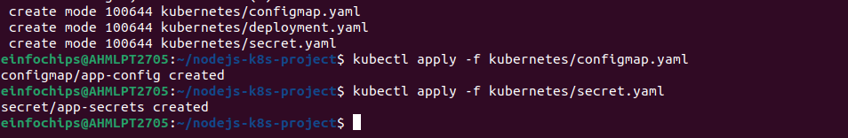
Apply the Deployment:
kubectl apply -f kubernetes/deployment.yaml
